User Documentation

**Faculty Research**

**Database**

ISTE 330.01

Team 14

Name Email

Dominico Tran dxt4298@g.rit.edu

Ellie Parobek arp6333@g.rit.edu

Kevin Lozano kxl3544@g.rit.edu

Rachael Simmonds rms1252@g.rit.edu

Vignesh Kumar vk4534@g.rit.edu

Intended Audience- The Public, Student, and Faculty Members:

Users:

There are three types of users: student, faculty, and public. Each user will be able to view the site but only students and faculty will be able to log in with a username and password while the public can search up projects and contact the faculty who created them.

Student:

Each student has the ability to work with a faculty member on the project they have created or create a project that can be displayed on the website and stored in the database. They would need a username and password to get into the database. They have the ability to request which faculty member(s) they want to work with and see who is working on what. In order for a student to work on a project, they must send a request ticket to the specific faculty member(s).

Faculty:

Each faculty member will have access to creating, updating, inserting, and deleting projects and information to and from the database. They will be able to accept/decline requests from students and also be able to read emails while accepting/declining requests from the public users. The faculty also have the ability to make changes to their previous projects rather than deleting it and reuploading the whole project.

Public:

The public can only view the website and the finished projects that have been added to the site. They can search for the projects and also email the faculty who have created the project itself and request for a meeting or for them to present at their school.

Description of Functions and How to Use Them

Insert:

The students can insert information in their project once it is approved by a faculty member. The Faculty can insert projects into the database which are displayed on the site when searched for. The public cannot insert anything.

Update:

The students are allowed to update their projects. The Faculty are also allowed to update students projects and their own and whoever else’s projects they are involved in. They are also able to update request made by students and the public. The public cannot interact with this function.

Delete:

The students can delete their request for a project or to work with a faculty member. The faculty member is allowed to delete information out of the database and delete any projects that have plagiarised previous ones or ones that are not efficient enough after completion. The public cannot interact with this function.

Sketches:

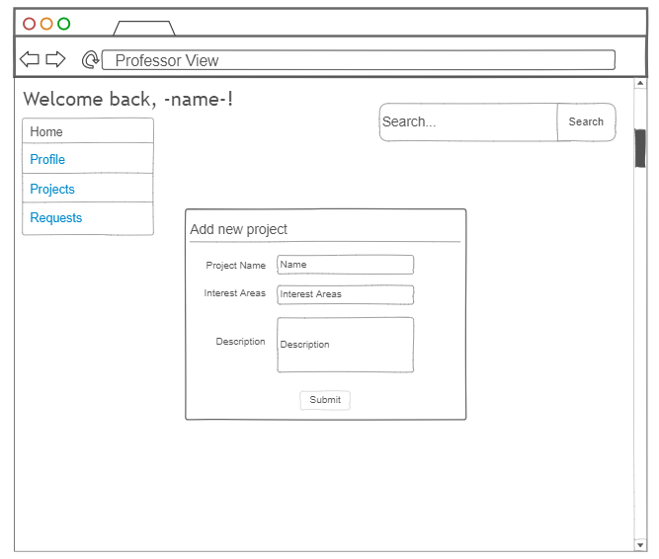

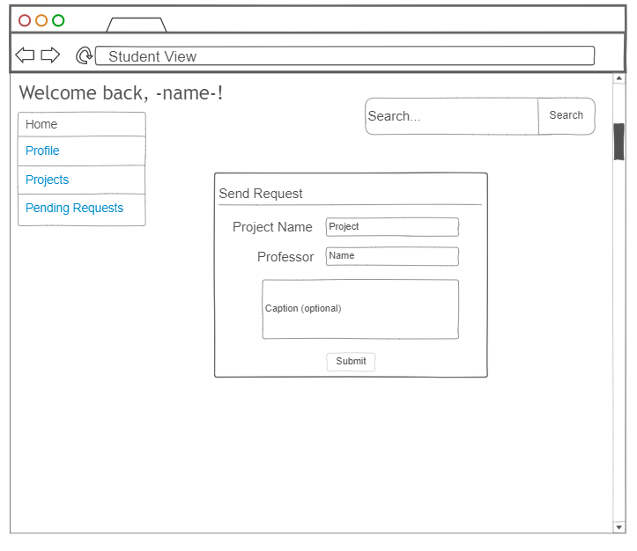

Menu Trees:

